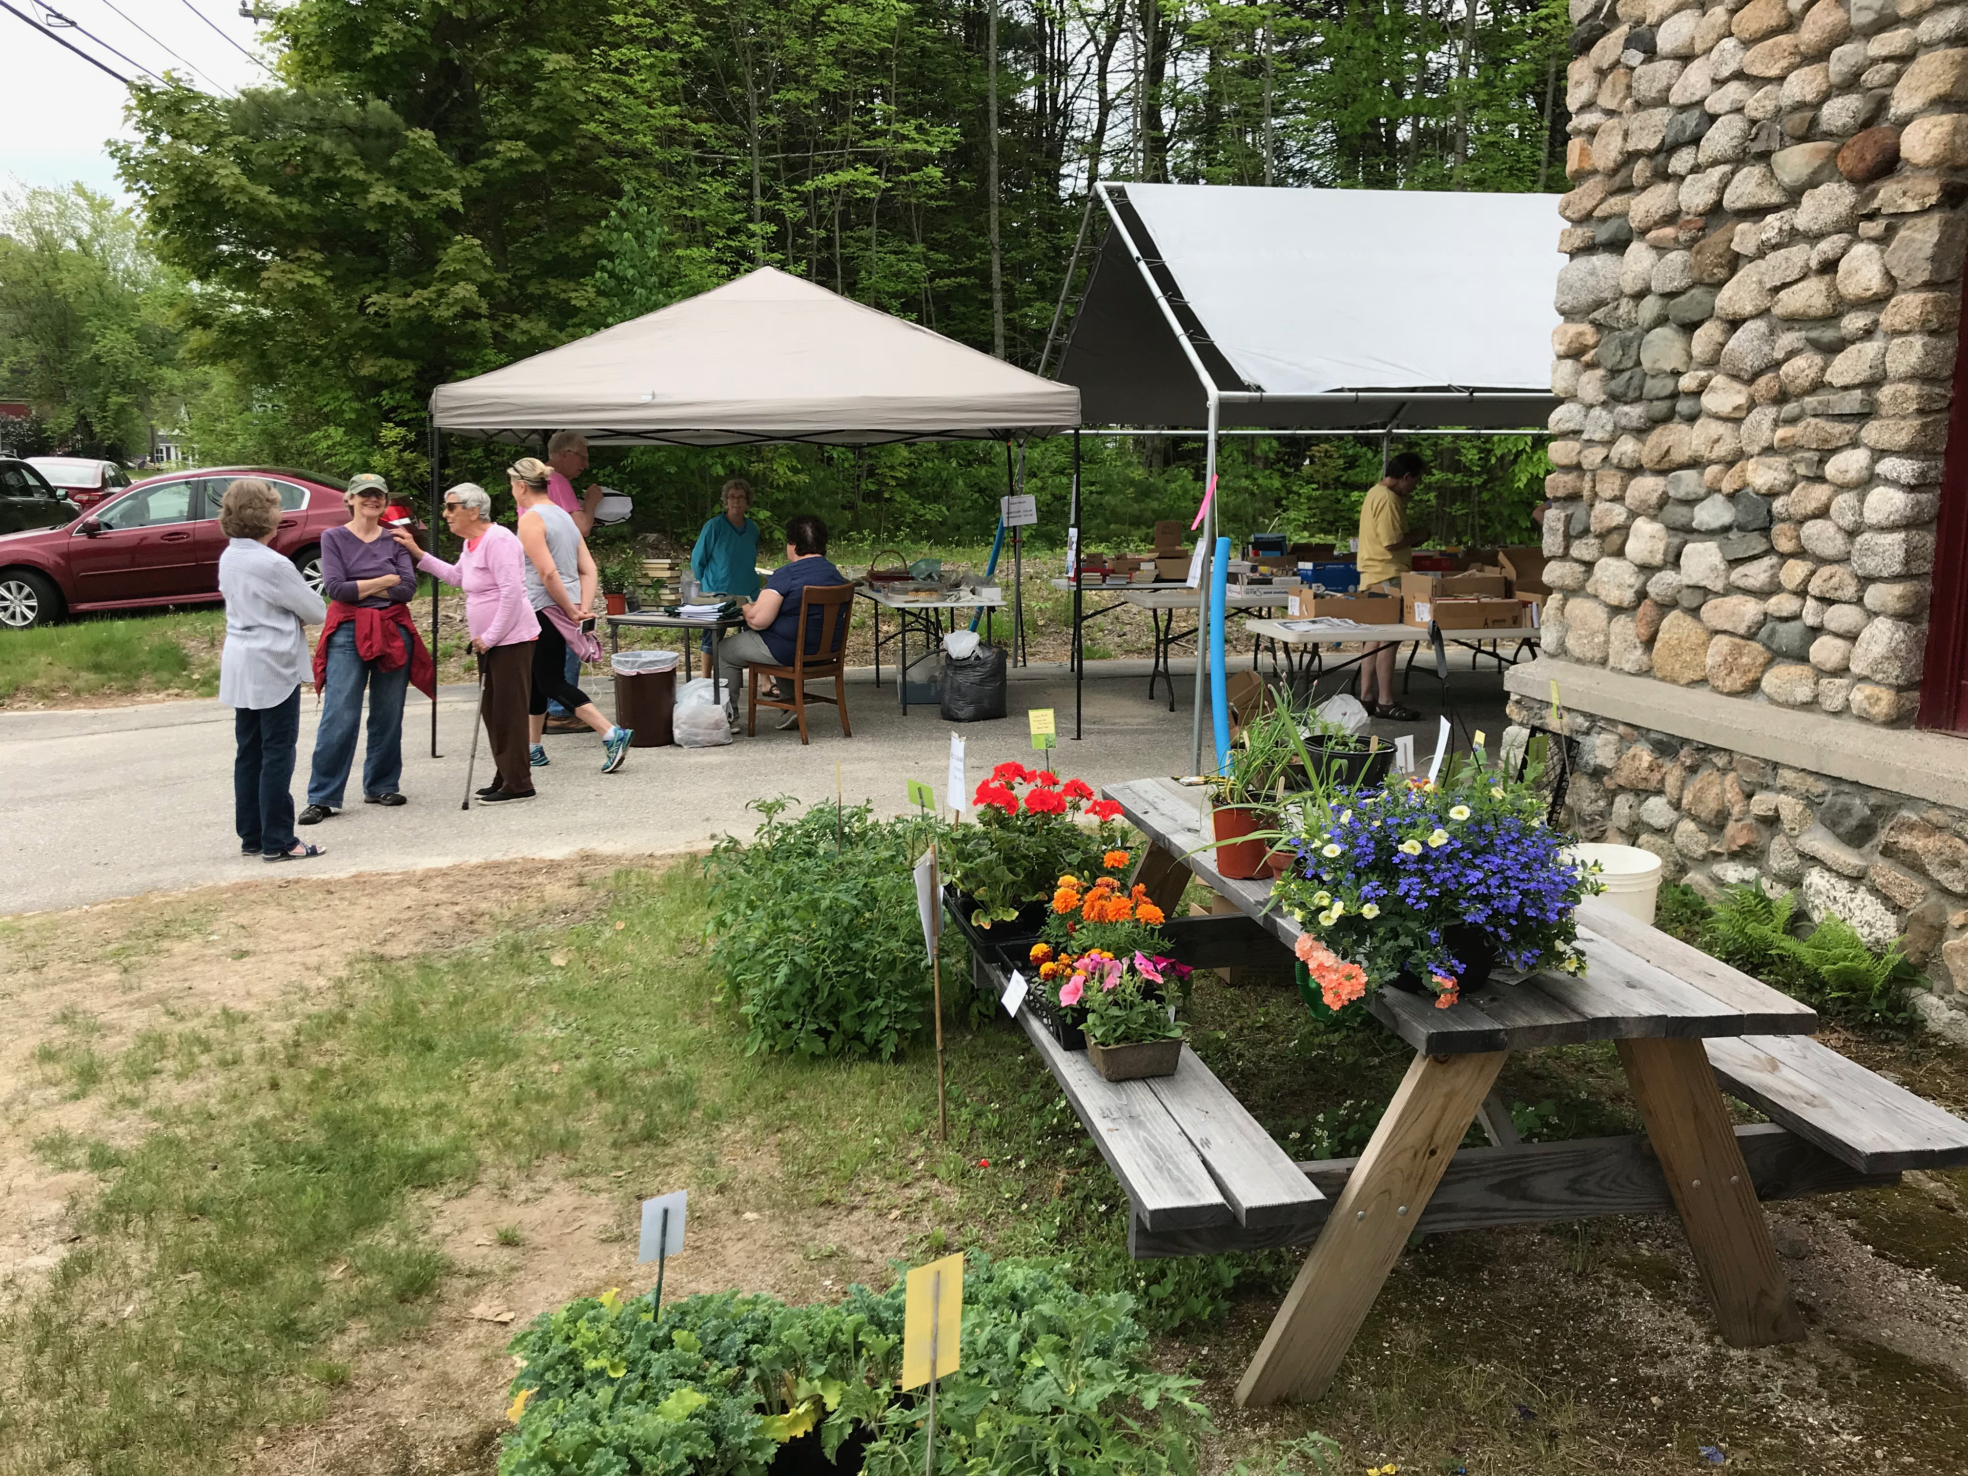
It's that time again! The Annual Bake, Book & Plant Sale will be at Spaulding Memorial Library, May 25, 9-1. Delicious home baked goods, books galore and donated plants. Rain or shine!

