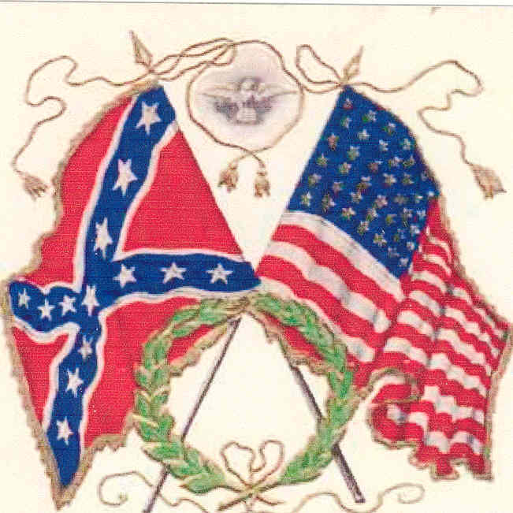

Civil War Novelist
Paul St. Cyr
Spaulding Memorial Library
Sat., Aug. 18, 7PM
Will talk about his research and his books about a confederate soldier during and after the war. 282 Sebago Rd. (Rte. 114)
FMI 787-2321

